Crosstabulations and the chi-square test: Worked Examples

The tables below show different explanatory (independent) variables crosstabulated with the dependent variable ‘The law should always be obeyed even when a particular law is wrong’ (zwronglaw). In each case the associated chi-square test is shown along with an interpretation of both the test and the table.
Paula Surridge, School of Sociology, Politics and International Studies, University of Bristol
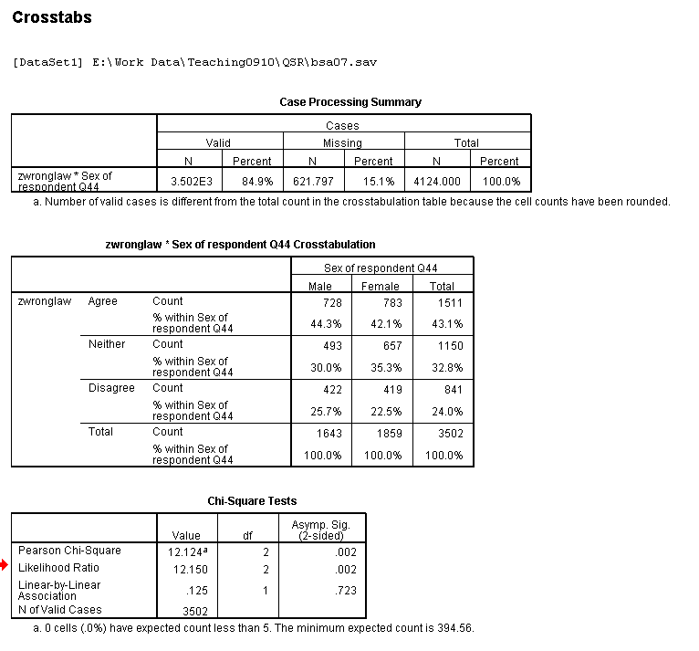
Example 1: Attitudes by gender
This test is valid. The relationship is significant (0.002 < 0.05)
Main difference is that females more likely to opt for middle response category.
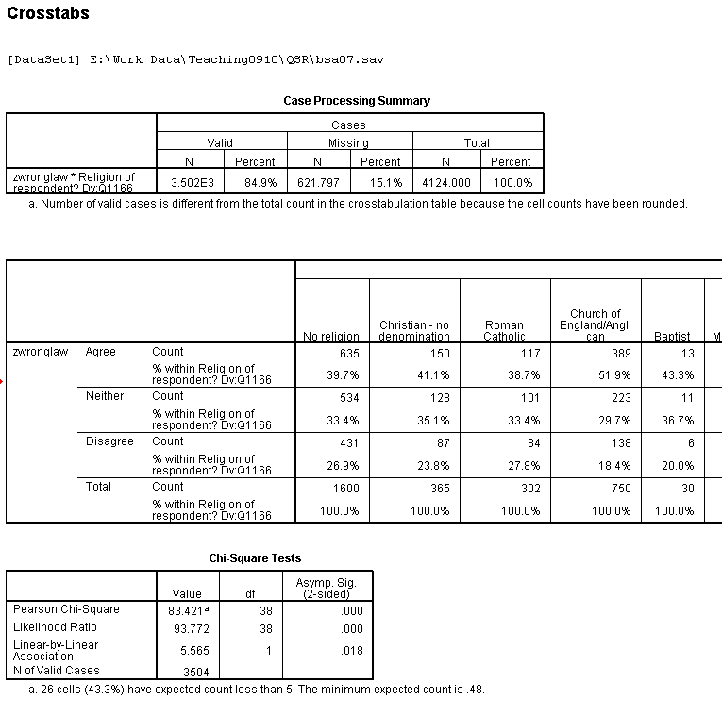
The minimum expected value is less than 1
Too many cells have expected values less than 5
Example 2: Attitudes by Religion (unrecoded)
This is an extract of the full table.
This test is not valid. Religion must be recoded in order to make the test valid and the data more interpretable.
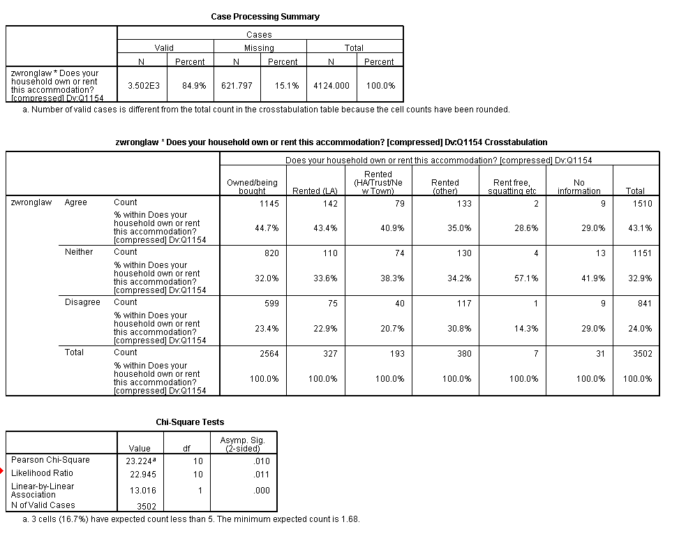
Only 7 respondents are in the ‘rent-free’ category. It would be best to recode the variable to either add these to one of the other categories or to remove for analysis purposes. Similarly the 31 with No information could be excluded from analysis.
Example 3: Attitudes by housing tenure
This test is valid. The relationship between attitudes to obeying the law and housing tenure is significant. However, there are some very small cell sizes in the tables and so it would be better to recode housing tenure despite the test being valid.

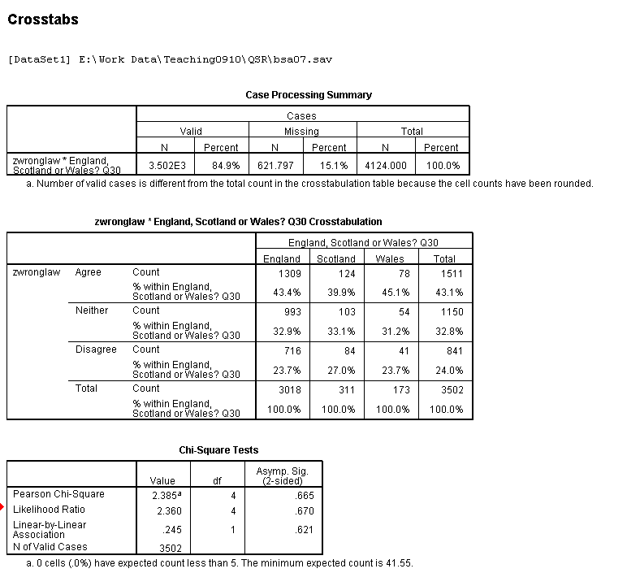
The statistical significance is not less than 0.05 therefore we do not reject our null hypothesis that there is no relationship between the two variables.
Example 4: Attitudes by country of residence
This test is valid but the relationship is not statistically significant. There is no difference in attitudes to obeying the law based on the country within the UK.

